# Hand Cricket

Submitted in partial fulfillment of the requirements of the degree

**BACHELOR OF ENGINEERING IN** **COMPUTER ENGINEERING**

By

**Pandey Samay – B/9**

**Patil Adwait– B/11**

Supervisor

**Prof. Keerti Kharatmol**



**Department of Computer Engineering**

**K.C College of Engineering and Management Studies and Research**

**Mith Bunder Road, Near Hume Pipe, Kopri, Thane (East)**

**University of Mumbai**

**(AY 2023-24)**

# CERTIFICATE

This is to certify that the Mini Project entitled “**Hand Cricket”** is a bonafide work of **Pandey Samay (B/9) & Patil Adwait (B/11)** submitted to the University of Mumbai in partial fulfillment of the requirement for the award of the degree of **“Bachelor of Engineering” in** **“Computer Engineering”.**

### (Prof. Keerti Kharatmol)

Supervisor

### (Dr. Mahesh Maurya) (Dr. Vilas Nitnavare)

Head of Department Principal

# Mini Project Approval

This Mini Project entitled “Hand Cricket**”** by **Pandey Samay (B/9) & Patil Adwait (B/11)** is approved for the degree of **Bachelor of Engineering** in **Computer Engineering.**

## Examiners

**1………………………………………**

(Internal Examiner Name & Sign)

### 2…………………………………………

(External Examiner name & Sign)

Date:

Place:

# Contents

### Abstract 5

### Acknowledgments 6

### Introduction

* 1. Introduction **7**
  2. Motivation  **8**
  3. Problem Statement & Objectives **9**

### Literature Survey

* 1. Survey of Existing System **10**
  2. Limitation Existing system or research gap **11**
  3. Mini Project Plan & Contribution **12**

### Proposed System

* 1. Introduction **14**
  2. Architecture/ Framework **15**
  3. Algorithm and Process Design  **16**
  4. Block Diagram/ Architecture  **17**
  5. Flowchart **18**
  6. Data Flow Diagram **19**
  7. Activity Diagram **21**
  8. Details of Hardware & Software **22**
  9. Experiment and Results **23**
  10. Conclusion and Future work. **25**

### 

**Abstract**

Cricket as a game is worldwide famous sport enjoyed by people all across the world. Talking about cricket in gaming, there are many games already existing exploring all the different modes of cricket. But “Hand Cricket” in particular although may have been already implemented, the game was not very advanced or intriguing for the player to enjoy playing the game. Our "Hand Cricket" application is designed to provide users with an engaging and interactive experience of the popular street game, Hand Cricket, in a digital format. This application provides players to compete with a computerized opponent providing them with a user friendly interface. This game currently only allows single player mode competing with a computer, allows them to input using buttons, increments score of both, and displays multiple animations keeping the user engaged.

**Acknowledgement**

We, Samay Pandey and Adwait Patil, would like to express our heartfelt gratitude to all those who contributed to the successful completion of the "Hand Cricket" project. Their support, guidance, and encouragement played an invaluable role in bringing this vision to fruition.

We are profoundly thankful to our project supervisor Mrs. Keerti Kharatmol, whose expertise and guidance provided the necessary direction and mentorship throughout the development process. Their valuable insights and encouragement were instrumental in shaping this project.

We extend our thanks to our friends and colleagues for their continuous support, feedback, and enthusiasm for the project. Their feedback and testing were vital in refining the application.

We also appreciate the constructive feedback and encouragement from the user community. Their valuable insights and suggestions have helped us enhance the application.

This project has been a labor of love and passion, and it wouldn't have been possible without the collective efforts and support of everyone mentioned above.

**Introduction**

**1.1 Introduction**

"Hand Cricket" is a specially crafted Android application that aims to bring the cherished street game of Hand Cricket into the digital realm, providing users with an enthralling and interactive experience. This app serves as a virtual playground for those who fondly remember playing Hand Cricket during recess in school. It transforms the traditional game into an engaging digital format, allowing players to indulge in thrilling matches.

One of the standout features of this application is the opportunity for players to challenge a computerized opponent. Instead of playing against a human opponent, the app offers a computerized adversary, making it accessible for solo play. This adds an element of competition and strategy to the game, ensuring that players can enjoy the game at their own pace, honing their Hand Cricket skills, and competing against a formidable virtual opponent.

Whether you're looking to relive the nostalgia of Hand Cricket from your childhood or experience it for the first time, "Hand Cricket" provides a platform that combines the familiarity of the game with the convenience of modern technology, making it an ideal choice for fans of the game.

**1.2 Motivation**

Creating the "Hand Cricket" application has been a journey filled with passion, determination, and creativity. While embarking on this project, I have drawn inspiration from the simple joy and excitement that the nostalgic game of hand cricket has brought to countless people, especially during their childhood. As I share my motivation for developing this application, I hope it resonates with the spirit of fun, nostalgia, and innovation that has driven me.

1. Rekindling Nostalgia: I was inspired by the nostalgia associated with hand cricket. This game is a cherished part of many people's childhoods, and I wanted to create a digital version that could help people relive those joyful moments.

2. Spreading Joy: Hand cricket is a game that transcends age and boundaries. It brings a smile to the faces of people, young and old. I wanted to share this joy with a broader audience, not just those who are familiar with it but also the newer generations who may have never experienced it.

3. Preserving Traditions: Hand cricket is a traditional street game that, in many places, is gradually fading into obscurity due to changing lifestyles and technologies. I wanted to contribute to preserving this wonderful tradition by bringing it into the digital age.

4. Creating a Unique Experience: The challenge of designing a realistic and engaging virtual opponent for hand cricket fascinated me. The prospect of crafting a virtual opponent that would test the player's skills and strategy was a motivating aspect of this project.

5. Innovative Technology: I saw an opportunity to blend a childhood game with modern technology, creating a unique and accessible experience. The potential to leverage mobile devices to replicate the hand cricket experience was intriguing.

6. Community Building: I envisioned the "Hand Cricket" app as a means to connect with a community of hand cricket enthusiasts. The idea of players sharing their scores, experiences, and even relatable stories added a sense of community to the project.

7. Continuous Improvement: With every development stage, I felt motivated to improve and enhance the application. Whether it was refining the algorithms, optimizing the user interface, or incorporating feedback from players, the drive for continuous improvement was a driving force.

8. Personal Fulfillment: Lastly, the process of creating this application has been deeply fulfilling for me. Seeing an idea transform into a fully functional and enjoyable mobile game has been a source of immense pride and satisfaction.

In conclusion, the "Hand Cricket" application is not just a project but a result of nostalgia and a testament to the power of creativity, technology, and a passion for preserving traditions and spreading joy. The motivation to create this app has been rooted in the belief that games like hand cricket have the power to bring people together, evoke smiles, and create lasting memories.

**1.3 Problem Statement & Objectives**

**Problem Statement**

The problem at hand is the lack of an easily accessible and engaging digital platform for people to enjoy the classic game of hand cricket. In a world where traditional street games are gradually losing their popularity, there is a need for an application that captures the essence of hand cricket, offers players the opportunity to compete against a computer opponent, and preserves the nostalgia associated with this game.

**Objectives**

1. Development of "Hand Cricket" Application: Design and develop an Android application named that replicates the hand cricket experience.

2. User Engagement: Create a user-friendly and intuitive interface that appeals to both existing hand cricket enthusiasts and newcomers.

3. Gameplay Realism: Implement a virtual opponent capable of simulating a human opponent, offering a challenging and enjoyable experience.

4. Scoring and Performance Tracking: Implement a real-time scoring system to display the number of runs scored and target set during the match, enabling players to track their performance and improve their skills.

5. Offline Accessibility: Ensure that the application can be used offline, allowing users to enjoy the game without requiring an active internet connection.

6. Preservation of Tradition: Contribute to the preservation of the hand cricket tradition by bringing it into the digital age and passing it on to a new generation of players.

7. Innovation: Innovate throughout the development process, continually seeking ways to improve the application.

8. Personal Satisfaction: Gain personal satisfaction from the successful creation and deployment of the "Hand Cricket" application, bringing joy and nostalgia to players.

The objective of this project is to create a digital platform that not only captures the essence of hand cricket but also ensures it remains accessible, enjoyable, and engaging for players in the digital age.

**Literature Survey**

**2.1 Survey of Existing System**

Few hand cricket applications created by lone developers are available on the internet. One such application is “Hand Cricket” by shijinmathew012 on GitHub.

Source: - [shijinmathew012/HandCricket: Android app of handcricket game (github.com)](https://github.com/shijinmathew012/HandCricket)

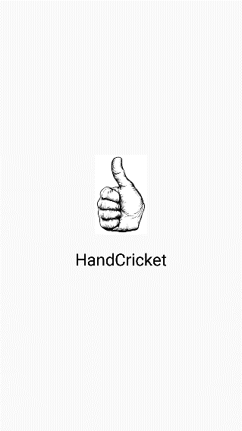 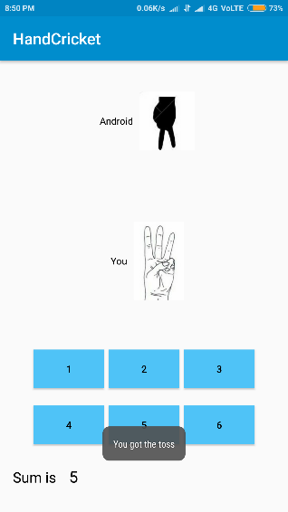 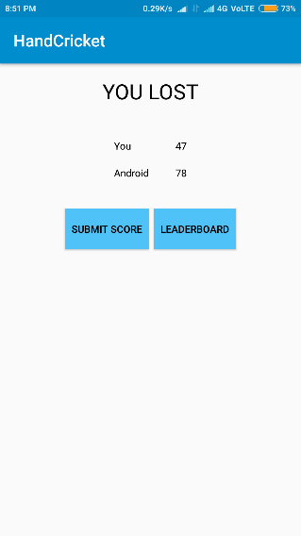

This Hand cricket app that already existed on GitHub has some better and some worse features. In context to remembering highscore the app already existing is better as it has a leaderboard screen showing the user their past scores. In the context of animation the app’s animation is quite worse than our owns as it only shows images rather than live animation making it less lively.

**2.2 Limitation Existing system or research gap**

The above application is a skeleton application which lacks user friendly elements and a immersive experience.

The app can be enhanced using animations, sound effects, immersive backgrounds, etc.

**2.3 Mini-Project Plan and Contribution**

**Project Overview:**

The Hand Cricket app is designed to bring the classic street game of Hand Cricket to digital platforms, offering an engaging and interactive experience. The project's primary objective is to develop a user-friendly application for Android.

**Project Goals:**

1. Create a user-friendly, intuitive Android app for Hand Cricket.

2. Offer a digital platform for users to relive the nostalgia of the traditional game.

3. Enable solo play against a computerized opponent for entertainment and skill development.

**Project Scope:**

The scope of the project includes:

- Development of an Android app with a user-friendly interface.

- Integration of a computerized opponent for single-player mode.

- Inclusion of scoring and match statistics.

**Project Timeline:**

- Phase 1: Planning and Design (2 weeks)

- Phase 2: Development and Testing (8 weeks)

- Phase 3: Deployment and Launch (2 weeks)

- Total Project Duration: 12 weeks

**Roles and Responsibilities:**

- Developer: Samay Pandey

- UI Designer: Adwait Patil

**Contributions and Deliverables:**

- Developer:

- Develop the Android application, including the user interface and gameplay features.

- Implement computerized opponent functionality.

- Test and debug the application.

- UI/UX Designer:

- Design the user interface for the app.

- Create visual assets, including graphics and icons.

- Ensure a user-friendly and visually appealing design.

Workflow and Collaboration:

- Regular team meetings were be held to discuss progress and address any issues.

- Code is version-controlled using Git to manage changes efficiently.

Documentation and Training:

- Develop user guides and help documentation for app users.

- No training is required for end-users as the game is straightforward.

Conclusion:

This "Project Plan and Contribution" document outlines the project's goals, scope, responsibilities, and timeline for the development of the Hand Cricket app. The team is committed to delivering an engaging and user-friendly digital version of the classic street game.

**Proposed System**

**3.1 Introduction**

"Hand Cricket" is a thoughtfully designed Android app that strives to transport the beloved street game of Hand Cricket into the digital sphere, offering users an immersive and interactive experience. This application acts as a virtual arena for individuals who have fond memories of playing Hand Cricket during school recess. It reinvents the conventional game into an exciting digital format, enabling players to partake in exhilarating matches.

**3.2 Architecture / Framework**

The application consists of multiple ‘activities’ which are basically canvases for each screen. The following activities make up our app: -

i) loading screen –loads up the app

ii)toss screen - includes progress bar and toss event

iii) main activity – where main execution takes place

iv) rules – a text only activity containing instructions

v) credits – a text only activity with developer details

**I]Loading Screen**

This activity just loads up the game indicating with a progress bar showing how much progress has already been completed.

**II] Toss Screen**

This activity is the first to be called when the application is launched. It comprises of 5 elements – a progress bar & 4 buttons. The buttons are: -

i) heads

ii) tails

iii) bat

iv) bowl

Initially the ‘heads’ & ‘tails’ buttons are set to visible while ‘bat’ & ‘bowl’ buttons are invisible. If and when the player wins the ‘toss’ event, the ‘heads’ & ‘tails’ buttons are set to invisible and the ‘bat’ and ‘bowl’ buttons are made visible. If the player loses the ‘toss’ event, the main activity is directly called. Else it is called after the player had made their selection from ‘bat’ & ‘bowl’.

**III] Main Activity**

This activity is the heart of the application where the main game is played. It consists of 2 video windows, 2 text views and 9 buttons. The buttons are: -

i) pause

ii) rules

iii) reset

iv) ‘1’

v) ‘2’

vi) ‘3’

vii) ‘4’

viii) ‘5’

ix) ‘6’

**3.3 Algorithm and Process Design**

**Steps-**

1]The app starts with the loading screen showing the progress of the app opening on the progress bar

2]The app then leads to the Toss page where the user chooses an option between heads and tails

3]The lottie animation plays and shows what was the outcome of the toss

4]If the user wins the toss he gets to choose between batting and balling else the computer chooses for its own and shows who is batting and who is balling and then leads to the Main activity

5]In the Main activity there is a rules button that opens up another activity explaining the rules for the game to the user. The user can exit that activity with the cross button given on top right of the newly opened rules activity

6]In the Main activity there is a pause button in which there are 3 options namely –

i)Resume – It resumes the game ending the pause

activity

ii)New game – It loops back to the toss activity

page giving the user a fresh start to

the game

iii)Credits – It shows the people who have

contributed to the project

7]There are buttons 1 to 6 which the user can click on indicating that it’s the choice they choose and computer generates a random number which is then compared in the backend. Both their choices are then displayed on the screen via lottie animation.

8]If their choices are different the score is then added to the batsman and the user can click another button after the lottie animation has finished

9]If their choices are same that means the batsman is out and then the “Out” animation is played indicating batsman is out

10]After the 2nd innings if the user wins the game then the “Victory” animation is played indicating that the user won whereas if the bot wins, “Defeat” animation is played indicating that the bot wins

11]After the game ends the user cannot press any more buttons such as 1 to 6 and rules and thus has to reset the game

12]The reset button near the top left of the screen resets the game but does not loop back to the loading screen except just resets the score and target going with the same order of batting and bowling between the user and the bot

**3.5 Block Diagram/ Architechture**

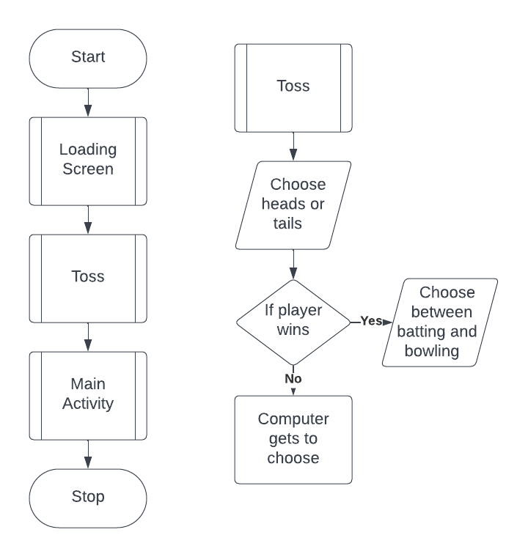

**3.5 Flowchart**

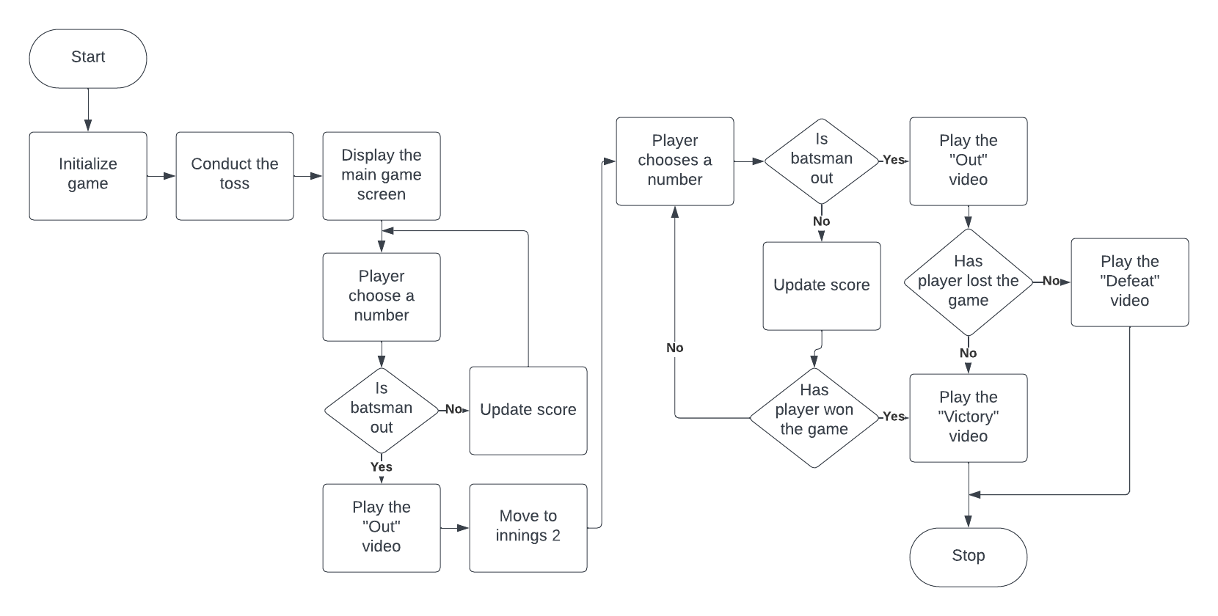

**3.6 Data Flow Diagram**

**Level 0**

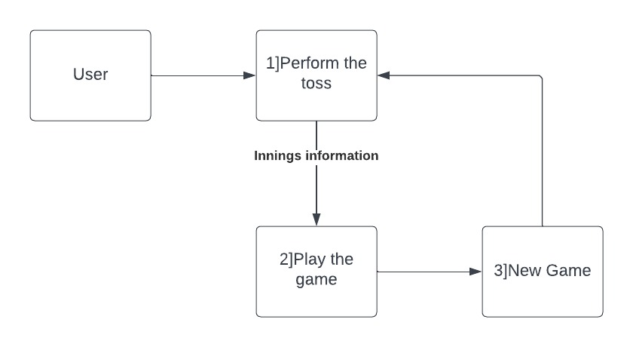

**Level 1**

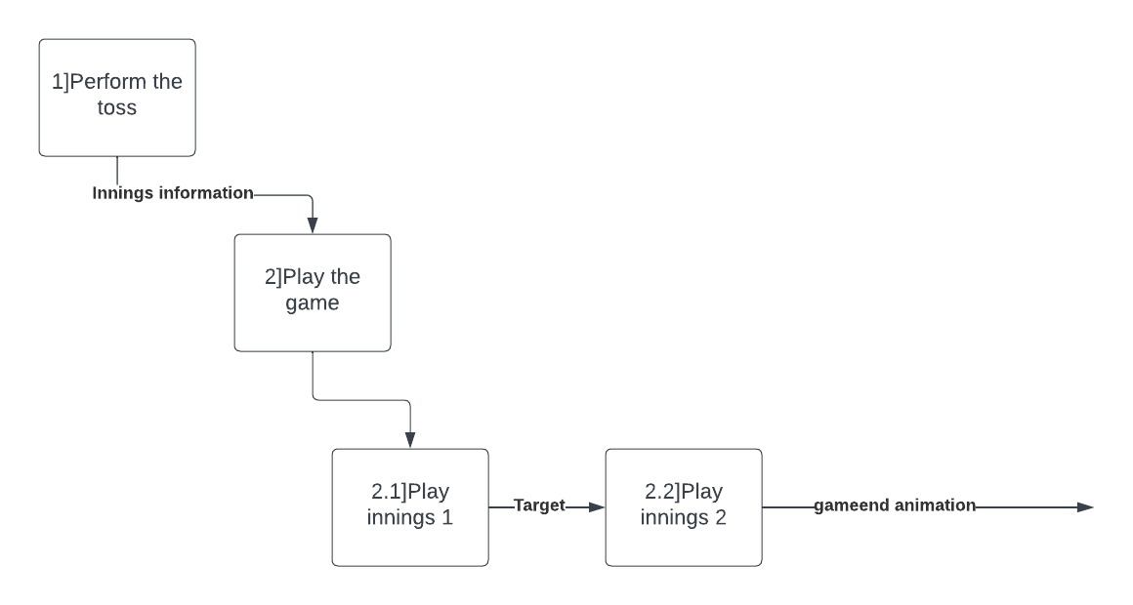

**Level 2**

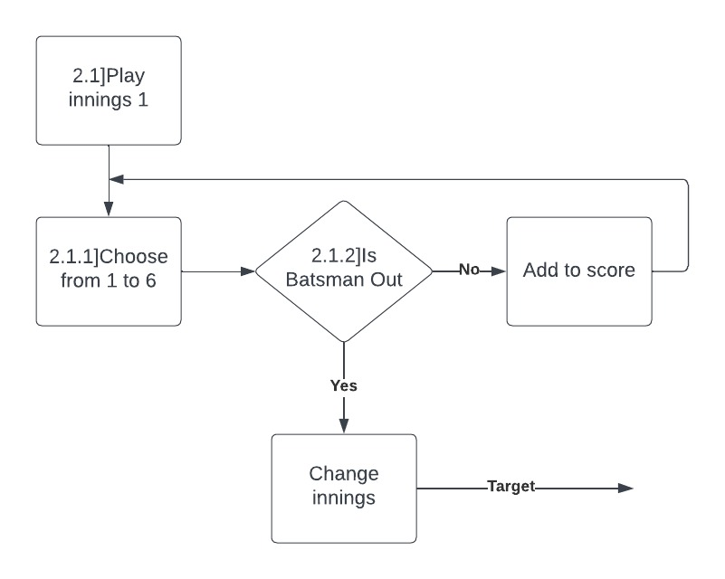

**3.7 Activity Diagram**

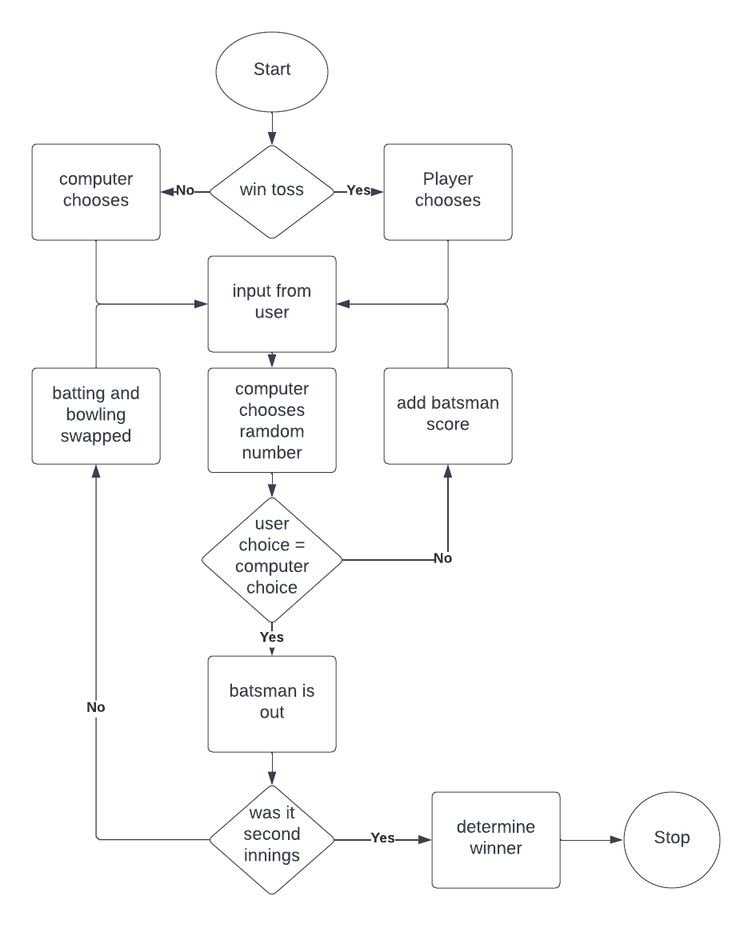

**3.8 Details of Hardware & Software**

Hardware Requirements: -

1. Touch Screen Interface inclusive Device
2. 2 GHz or greater Quad Core Processor
3. 4 GB or more RAM
4. 32 GB Storage

Software Requirements: -

Android 13 and above

**3.9 Experiment & Results**

**1]Loading Activity**

This activity is the first to be displayed when the application is launched.

It only consists of a loading bar at the bottom.

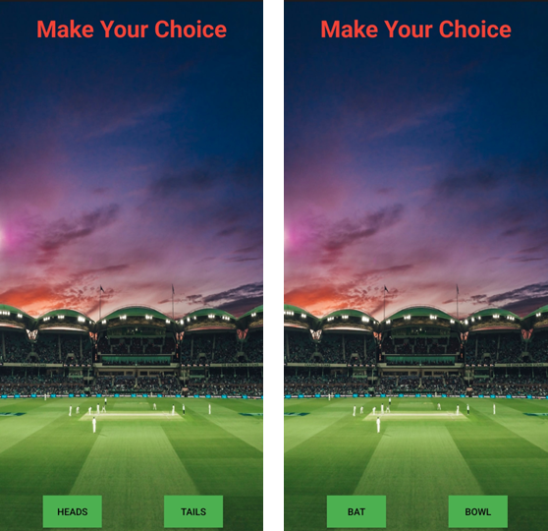**2]Toss Activity**

This activity is the next to be displayed.

It allows the user to select their input for the toss.

If user wins, they are allowed to choose between batting and bowling. Else, computer chooses.

**3]Main Activity**

This activity is the heart of the application.

It allows the user to select their input for the main algorithm.

**4]Pause Menu**

The pause menu displays the option to start completely new game.

The credits menu displays the developers information.

**5]Animations**

Animations have been included in the application for a more immersive experience.

The animations are made using Unity.

**3.10 Conclusion and Future Work**

In conclusion to all, this application is intriguing and alluring to all the users interested in playing and provides them with an interactive gaming experience along with the feeling of nostalgia.

In future this app can be improved through many ways such as allowing the user to customize carious aspects of the game, adding leaderboards and achievements tab to the game, and improving on the already existing visual and audio effects.